**Helping Hands**

Deliverable 2

3/28/2019

Anusha Malla

Briana Jenkins

Daniel Bae

Haythem Abdelkhalek

Trmnit Tesfatsion

Wonjin (James) Choi

IS 436 - Structured Systems Analysis and Design

**Interviews**

|  |
| --- |
| **Interview Notes Approved by: Ira Fabri** |
| **Person Interviewed: Ira Fabri**  ***Assistant Director of Tutoring***  **Interviewer: Haythem, Briana, James**  **Date/Time: 03/15/2019 at 2:30pm** |
| **Purpose of Interview:**   * Gain an understanding of how tutoring sessions are being scheduled and tracked. * Determine what is required for the future system. |
| **Summary of Interview:**   * Tutoring sessions are currently being made through a third party app called StudyTree and this slows down support when it’s needed. * Ira is responsible of scheduling weekly appointment, contacting StudyTree support whenever it’s needed, and coordinate between tutors and students when schedules do not match. * Ira reports to Cassie with weekly and monthly StudyTree generated reports. * The new systems needs to allow tutors to make changes to their own schedules. |
| **Open Items:**   * Get a daily report from Ira. * Get a copy of Ira’s tutors evaluation form. |
| **Detailed Notes:**  Q: What is your role in the supervisor position?  A: I manage tutoring sessions, this means adding, scheduling, canceling, and editing sessions. I also work very closely with StudyStree support team as I am responsible of fixing issues with the app that students or tutors encounter. I also evaluate current tutors and hire new tutors every semester.    Q: How many students tutors teach daily?  A: Right now, average daily students is around 8 students, but some days like Wednesdays, we get around 20 students, and Fridays around 2 students.  Q:How many tutors do you roughly have?  A: For this semester 73 and we usually never exceed 80.  Q: How does the current system make scheduling a student with a tutor convenient?  A: For an administrator, I simply login to the StudyTree website and create a session by choosing between the different options that match with the student needs. From a student perspective, the app is linked to Blackboard so they only see tutoring for their current courses  Q: What is your opinion on the study app?  A: The options it offers are excellent, but it has too many issues and bugs that makes it really difficult to use.  Q: How can the app improve its scheduling system to make it easier for students?  A: From what I heard from students, the whole concept of AI that helps you pick up available tutoring sessions is very confusing. Students like it when it’s simple and clear. It would be easier if students can log into the apps and see a list of the available sessions in the course they need help with right away. Students should also be able to choose if they want to make their appointment recurrent weekly or just once at a time. This will eliminate a lot of unnecessary emails exchanges between me and the students. We also need to create waitlists for sessions that are already booked. This way, students don’t have to constantly track if their favorite time for a session is available or not.  Q: How can the app improve its scheduling system to make it easier for tutors?  A: Tutors need to be able to input their own availability for tutoring on the app and change it at any time they need. Currently, all tutors send me their schedules and I have to enter them manually into the system. In addition to that, If a tutor is going to be absent for being sick or any other reason, they need to send me an email to ask me to cancel their sessions and then I have to send emails to the students to inform them that the session is cancelled and the reason of cancellation.  Q: How often do you get data reports and how can it be improved?  A: I can request reports anytime, but those reports are always bugged and it takes around 15 min to get one. For example: if a student cancel a weekly appointment, the report will keep showing 13 cancellations for every single week that session was supposed to happen. This makes it very difficult to interpret in Excel and visualize. I need simple spreadsheet with more accurate numbers that shows the difference between weekly sessions and one time sessions.  Q: Is there a feature on StudyTree that help you evaluate tutors? How do you currently evaluate students?  A: No. Right now, I have to assign tutors to evaluate their peers in their down time. They answer a questionnaire I shared with all tutors as a Word document. Every two week as I have to read those evaluations to make sure everything is going well, especially for new tutors.  Q: Would it help if the system included a tutor evaluation feature? How would this feature work?  A: Yes! I would like to have my questionnaire adapted and made available for tutors on the app. Instead of waiting for the evaluators to finish answering the questionnaire and sending it to me, I need to have a score of how well is the tutor being evaluated is doing as soon as session ends.  Q: How can the system help tutors prepare for their tutoring session?  A: Students need the ability to add information to their profile. For example: we need to know if a student needs special accomodation and provide it to them if needed.  Q: Does the system track No-shows?  A: No. This is an important feature we need to add to the current system in order to block students from booking sessions after 2 consecutive No-shows. |

|  |
| --- |
| **Interview Notes Approved by: Cassie** |
| **Person Interviewed: Cassie Hoddinott**  **LRC Director**  **Interviewer: Haythem, Briana, James**  **Date/Time: 3/16/19 at 3:30pm** |
| **Purpose of Interview:**   * Understand Cassie’s role in the tutoring center and how she interacts with the current system. * Determine what is required for the future system. |
| **Summary of Interview:**   * Weekly and monthly reports are crucial for the LRC to receive support from administration. * Administration should be able to assign tutoring classrooms to tutors. * Students should be able to create their profile to help tutors prepare for their sessions. * Direct messaging is needed between support and students. |
| **Open Items:**   * Get a weekly report from Cassie * Get the features analysis |
| **Detailed Notes:**  *Q:* What is your role in the supervisor position?  *A:* I am the director of the LRC. This means I get weekly reports from all the staff and analyze those reports to make strategic decisions.    *Q:* How many staff members can view and contribute to the StudyTree reports?  *A: Currently it is just Ira and I.*  *Q*: How is your role within StudyTree different than Irs’s?  A: Ira is the person who is in direct contact with the tutors, students, and StudyTree support. I am the one who fixes the number of tutors we can hire, the maximum number of sessions students can get, and answer to all the financial matters between LRC and UMBC.  Q: What makes using StudyTree to schedule tutoring convenient?  A: We started using StudyTree because it is cheap and it offers good data analytics and daily/weekly/monthly reports that help us make decisions. Before using this app, we used to make tutors and students fill out Google Forms which limit us in the amount of data we could collect about tutoring sessions.  Q: What is your opinion on the StudyTree app?  A: StudyTree was not programmed to work with a tutoring center like the LRC. It was mainly designed to put together tutors and students without going through any staff members which is impossible to do as any organization or University need to supervise and manage their tutors constantly.  Q: What are some improvements that could be made for the app?  A: First of all, there are too many issues and bugs in the app that makes it crash every 10 min and this needs to be fixed. Tutors need to be able to change their available times to tutor. Administrators should be allowed to assign classrooms to the session when they created. Right now, all session are listed to happen in “UMBC” but no other details. Students should be able to create a profile in order to add specific information about what they need help with, or if they need accomodations. Tutors should be able to create a profile to select what courses they want to mainly tutor and which ones they can potentially tutor.  Q: Is there a way communication between administration and students can become more efficient?  Q: Students should be able to ask for support directly on the app. Ira and I get around 50 emails every week from students and we have to transfer those email to support so they can solve their problems. This is extra work when we should be focus on more important tasks. |

**Document Analysis**

From the interviews that we have conducted, we have asked the representatives of the tutoring center to prepare us document(*From Supervisor: Scheduling system specs*) that display the requirements they need in the app we will be building. For instance, what they are looking to be implemented for tutors, students and supervisors. The representative have also shared an Excel sheet *(ASAC Scheduling Platform Comparison*) that compared different Scheduling Platform.

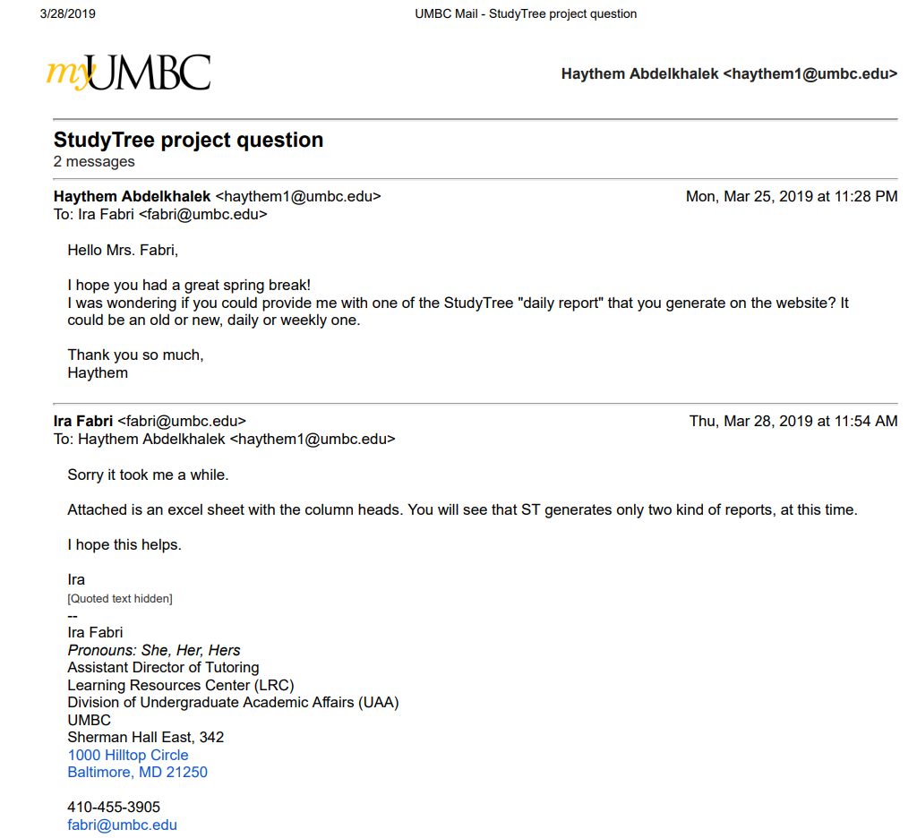

For Privacy issues, we were not allowed to share any reports containing data.

For the purpose of this deliverable, below is a list of the column names in the 2 possible reports. These reports are generated in a .xlsx document

**Tutoring Center Usage report**

Tutoring Center Name - Resource Name - Course - Session Id - PoolSession Id - Tutor First Name - Tutor Last Name - Tutor Email - Tutor SIS Id - Student First Name - Student Last Name - Student Email - Student SIS Id - Creator First Name - Creator Last Name - Creation Time - Scheduled Start Time - Scheduled End Time - Event Status - Event Deleted By - Event Deletion Reason - Event Deletion Time - Is No Show

**Confirmed sessions report**

Session Id - PoolSession Id - Resource Name - Course - Tutor First Name - Tutor Last Name - Tutor Email - Tutor Average Rating - Student First Name - Student Last Name - Student Email - Start Time - End Time - Session Duration - Session Review Score By Student - Session Review Score By Tutor

Current improvements and features requested by Ira from StudyTree to implement in the next update.

**Scheduling system specs**

Required

1. **Create as many schedules as necessary**
2. **Decide number of allowed appointments per week**
3. **Allow different start/end times and lengths of appointments**.
4. **Schedule accessible from multiple devices/locations**
5. **Students can search by topic**
6. **Forms (appointments, report, registration, etc.) customized easily**
7. **Waiting List**
8. **Send appt. confirmations/reminders, different times and formats (email or text or both)**
9. **Can create tutor profiles**
10. **Survey option**
11. **AU Email registration only**
12. **Track no-shows and block offenders**
13. **Generate reports and analytics**
14. **Good customer support**

Strongly preferred

1. Forms (appointments, report, registration, etc.) customizable differently for different centers.
2. Sync appointments with other calendars
3. Opening/closing hours is easy for tutors to do on their own
4. Online session capability

Preferred but not indispensable

1. Tracks sign ins/outs by student's number (good for SI and drop-ins)
2. Faculty referral and early alert system
3. Offers their own online tutors
4. Online chat/messaging function or text feature
5. Facebook integration
6. Tutor payroll
7. Interface with SIS

**Observation**

We started the observation by logging into Ira’s administrator account on StudyTree’s website and going through today’s list of sessions, March 15, to check the accuracy of the data before generating a StudyTree daily report. Ira pointed out that the number of sessions displayed in the schedule does not reflect the real number of session happening today. Few sessions were missing and few others showed a start time at 9:00am which is an hour before the Learning Resources Center opens. Then, we checked her inbox to check the nature of email exchanges she gets from tutors and students. At 3:15PM, just for that day, she had received 5 emails from tutors and 10 emails from students. It seemed that these emails had many things in common. Tutors would be asking about making changes to their schedules, as they are unable to do so with the current system and Ira has to do it manually, and students requesting weekly sessions instead of having to manually book sessions every week. Then we generated a daily StudyTree report to examine the data gathered for the tutoring center. Generating the report took about twelve minutes of loading time. The report showed the correct sessions scheduled with correct status “No-Show, completed, not started” but did not flag the repeated no-shows to block students with more than two absences in a row from booking new sessions. The report also showed thirteen cancellations for two students who cancelled their weekly appointment. From Ira’s perspective, this should show-up only once and a new column with the number of sessions being cancelled in a new column. Ira explained how having well accurate and well organized report is crucial as she uses them to show the Learning Resources Centers’ activities to UMBC administration.

**Questionnaire**

Our Questionnaire was created with Google Forms. Our group member Haythem Abdelkhalek works currently at the Learning Resources Center as a tutor. Haythem sent the questionnaire to all his current students and to other tutors so they can forward it to their own students. The questionnaire was sent to students on Sunday March 24th and responses were collected until March 27th. The Google Form was sent out to 16 staff and students, only 3 responded.

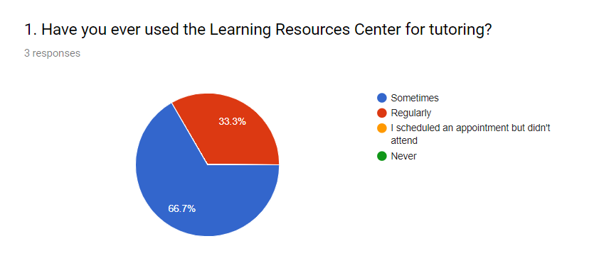

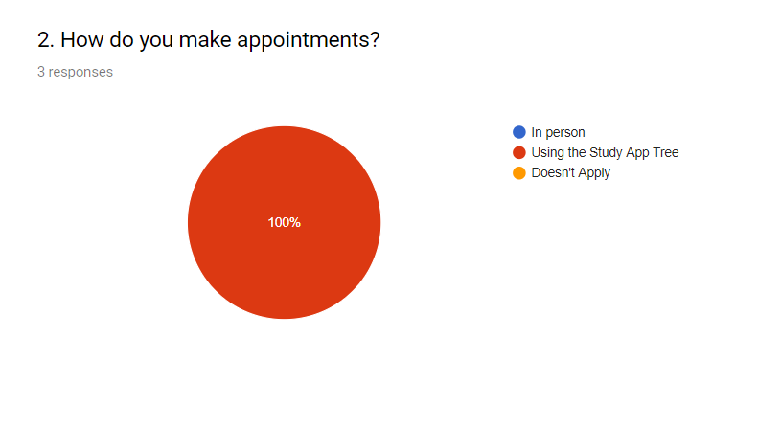

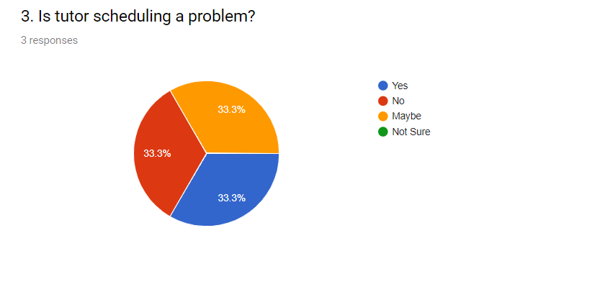

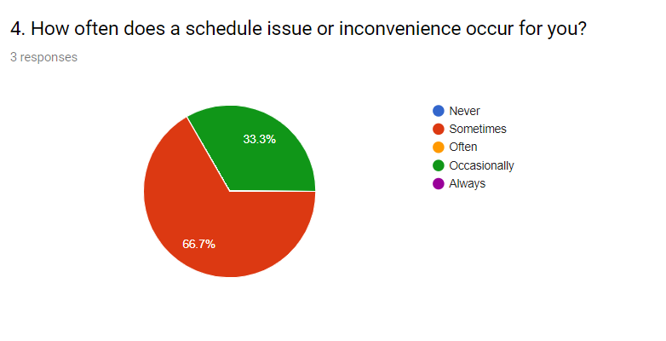

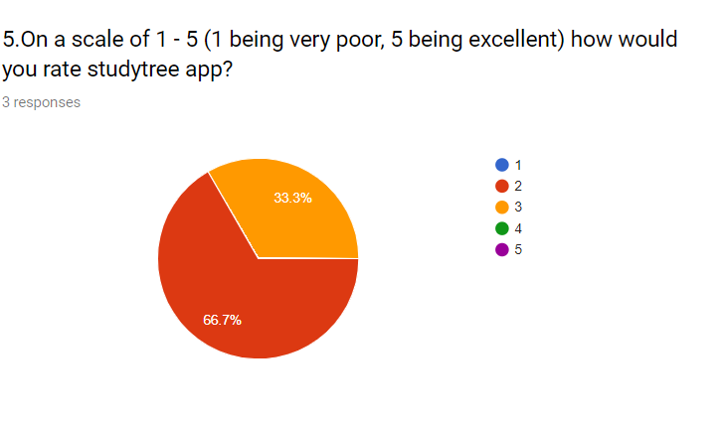

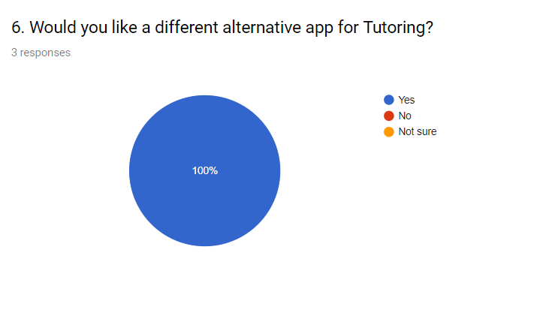

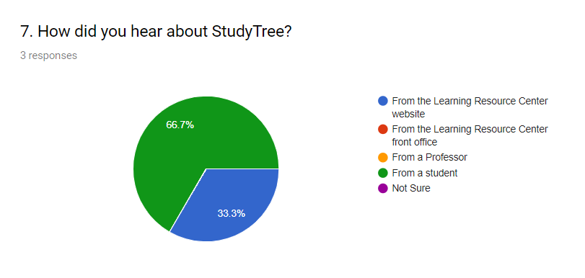

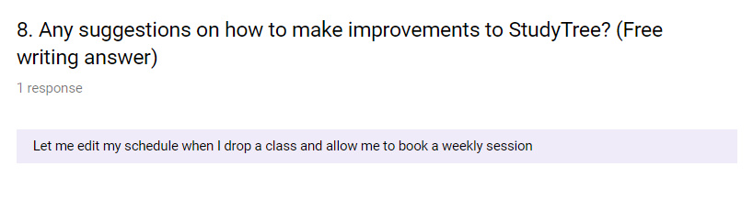

**Requirements**

* Functional

**Process-Oriented:**

1. Schedule Updating

1.1 The app would let the tutors go in and change their schedule around

1.2 Tutors can see how many students they are allowed to tutor weekly.

1.3 The app will allow tutors choose which hours they want to be “Available for booking” and which hours to be “Potential hours”

1. Appointments

2.1 The app will let the student the number of allowed appointment per week and per semester.

2.2 The app will send appt. Confirmation and reminders which can be text or email

**Information-Oriented:**

1. Registration Information

1.1 The app will have a AU email registration only.

1.2 The app will be able to create tutor/student profiles

1.3 The app will have a waiting list for booked sessions

1. Forms

2.1 The app will have forms that will be easily customized (reports,  
 appts.)

2.2 The app will allow students to search topics or subjects.

1. Reports

3.1 The app will have reports for daily, weekly, monthly and yearly activity.

* Non-functional

**Operational:**

1.1 The app will allow different start/end times and length of appointments

1.2 The app will generate reports and analytics

1.3 The app will be accessible to students on multiple devices and locations when wanting to change schedule or just schedule

**Performance:**

1.1 The app will have great customer support

1.2 The app will update every 15 minutes

1.3 The app will be available 24 hours a day

**Security:**

1.1 The app will track no-shows and block offenders after 2 consecutive No-shows

**Cultural and political:**  1.1 The app will have a survey option for students to take for feedback at the end of every semester.

**Use Case Analysis**

|  |  |  |  |  |  |  |
| --- | --- | --- | --- | --- | --- | --- |
| **Use Case Name: Registration** | | | **ID: 1** | | **Priority: High** | |
| **Brief Description:** This use case will have umbc email registration only, and will help create the tutor, student and supervisors profiles. It will also, able the students to be able to be waitlisted for booked sessions so they don’t have to keep checking the app for booked session to open up. Supervisors will be able to keep tract/ interact with students and tutors. | | | | | | |
| **Actor:** Students, Tutors and Supervisors | | | | | | |
| **Trigger:** Students can use the app to book a session with a Tutor and a Tutor can register in order to be matched up with a student. | | | | | | |
| **Type:** External | | | | | | |
| **Preconditions:**   * Student, tutor and supervisor must have a functioning umbc email * Tutors must be hired by the UMBC supervisor * Students, tutors, and supervisors must remember their login information * Supervisors must be authorized by UMBC to monitor tutors and students | | | | | | |
| **Normal Course**   1. Students and Tutors register with their UMBC email 2. A registration confirmation is sent to their email 3. Students/tutors can login with their email and password to on the app 4. Students can be waiting list for booked sessions 5. Supervisor can assign tutoring classrooms to tutors | | | | **Information for Steps**  → register for the app  ← confirmation information is sent  → registered users can logback in with their username/password  →students can be waitlisted for registration  → students books a session with a tutor, then classrooms for tutoring are assigned by supervisor to tutors | | |
| **Postconditions:**   * When waitlisted student is able to register for a session a reminder is sent via email. * Students should remember they login information for future login purposes * A classroom where a student and a tutor can meet is set | | | | | | |
| **Summary:**  **Inputs Source Outputs Destination** | | | | | | |
| Student and Tutor registration information | Student and Tutor | Registration is complete and | | | | student , tutor, supervisor |

|  |  |  |  |  |  |  |
| --- | --- | --- | --- | --- | --- | --- |
| **Use Case Name: Forms** | | | **ID: 2** | | **Priority: High** | |
| **Brief Description:** This use case describes how the app will have forms that can be customized to the students/tutors/supervisors needs. This can be used by students and tutors to customize their own appointments as well as the subjects they are interested in. The supervisor will also, be able to customize reports | | | | | | |
| **Actor:** students, tutors and supervisors | | | | | | |
| **Trigger:** The need of customizing of personal preference in regards tp appt and courses and reports | | | | | | |
| **Type:** External | | | | | | |
| **Preconditions:**   * Students, tutors, and supervisors must have be registered users of the app * There must have students and tutors that are actively engaged in order for a supervisor to be able to customize reports | | | | | | |
| **Normal Course**   1. Students and tutors can customize their schedules and courses before booking any sessions 2. Supervisors can customize reports before generating them | | | | **Information for Steps**  → students/tutors must login to the app  → customize schedule within the app  ← students and tutors are able to see their customized/updated schedule and courses  → supervisors must login to the app  →they can customize reports before generating them  ←customized reports are visible supervisors | | |
| **Postconditions:**   * Report has been generated | | | | | | |
| **Summary:**  **Inputs Source Outputs Destination** | | | | | | |
| Students/tutors schedules and preferred courses  Supervisors need for customizing reports | Student  Tuttor  Supervisor | Customized schedule and courses for students and tutors  Customized report | | | | Student  Tutor  Supervisor |

|  |  |  |  |  |  |  |
| --- | --- | --- | --- | --- | --- | --- |
| **Use Case Name: Updating Schedules** | | | **ID: 3** | | **Priority: High** | |
| **Brief Description:** This use case describes how the app will allow autonomy for tutors in regards to changing their schedule, the amount of hours they would like, and the number of students they will see per week. | | | | | | |
| **Actor: Tutors** | | | | | | |
| **Trigger:** Tutors preparation for their work week. This incorporates changes in schedule, and in hours to work. | | | | | | |
| **Type:** External | | | | | | |
| **Preconditions:**   * The tutor need to login into the system using a umbc id and password * The tutor must have an emergency change in schedule. * The tutor must know how many hours they would like to register for. | | | | | | |
| **Normal Course**   1. Tutors are able to access their schedule 2. Tutors can change their schedule    1. If they would like more hours, it can be checked in the database.    2. If they would like to release some tutoring session, student will receive a notice of a schedule change. 3. Changes in schedule will be recorded in the system. | | | | **Information for Steps**  ← log into system  → access to database  → available hours displayed  → notice of change in schedule sent  ← change in schedule for tutor  → new record processed in database | | |
| **Postconditions:**   * Tutor has a revised schedule * Notice is sent to student of revision if it pertains to the student. | | | | | | |
| **Summary:**  **Inputs Source Outputs Destination** | | | | | | |
| Tutor Access | Tutor | Revised schedule with notices being sent to students regarding the change. | | | | Student |

|  |  |  |  |  |  |  |
| --- | --- | --- | --- | --- | --- | --- |
| **Use Case Name: Appointments** | | | **ID: 4** | | **Priority: High** | |
| **Brief Description:** This use case will describe how and how many tutoring appointments can the students make per week with its confirmation as well as reminder via text or email. | | | | | | |
| **Actor:** Students | | | | | | |
| **Trigger:** Helping students book an appointment on time and remind them about the appointments. | | | | | | |
| **Type:** External | | | | | | |
| **Preconditions:**   * Student will need to login with their student id and password. * The students should know the limitation of appointment. * Student should select the means of reminder i.e. text or email. | | | | | | |
| **Normal Course**   1. Students can book the available appointments. 2. The appointment is received and acknowledged. 3. Appointments will be recorded in the system. 4. Confirmation and reminder of the booked appointment is sent. 5. Students can be waitlisted for tutoring sessions | | | | **Information for Steps**  ← log into the system  → access to the database  ← available/allowed appointment slot displayed  ←Needed appointment booked  →Confirmation of reserved appointment sent  →revised appointment slot displayed  →Reminder of an appointment sent  ← reminder of available/open previously waitlisted session will be sent | | |
| **Postconditions:**   * Students know the limitation of appointment and schedule on time and only when needed. * Confirmation is sent after booking an appointment. * Reminder is sent via text/email before the appointment time. | | | | | | |
| **Summary:**  **Inputs Source Outputs Destination** | | | | | | |
| Student information | Student | Necessary appointments made and a confirmation and reminder sent to the students. | | | | Tutor |

|  |  |  |  |  |  |  |
| --- | --- | --- | --- | --- | --- | --- |
| **Use Case Name: Reports** | | | **ID: 5** | | **Priority: High** | |
| **Brief Description:** This use case describes how the app will have forms that can be customized to the students/tutors/supervisors needs. This can be used by students and tutors to customize their own appointments as well as the subjects they are interested in. The supervisor will also, be able to generate reports that are need for evaluating the tutoring program. | | | | | | |
| **Actor:** Supervisor | | | | | | |
| **Trigger:** It is the end of a day, week, month and year | | | | | | |
| **Type:** Temporal | | | | | | |
| **Preconditions:**   * App can track activities done by students and tutors * Supervisor can customize reports | | | | | | |
| **Normal Course**   1. Daily, weekly, monthly and yearly reports are generated | | | | **Information for Steps**  → Supervisor requests customized report  ←Outcome of reports is displayed to supervisor | | |
| **Postconditions:**   * Reports have been generated based on the supervisors need | | | | | | |
| **Summary:**  **Inputs Source Outputs Destination** | | | | | | |
| Request of reports by supervisor | Supervisor  App Database | Reports are given by the app based on daily, weekly, monthly, and yearly basis | | | | Supervisor |

USE CASE DIAGRAM:

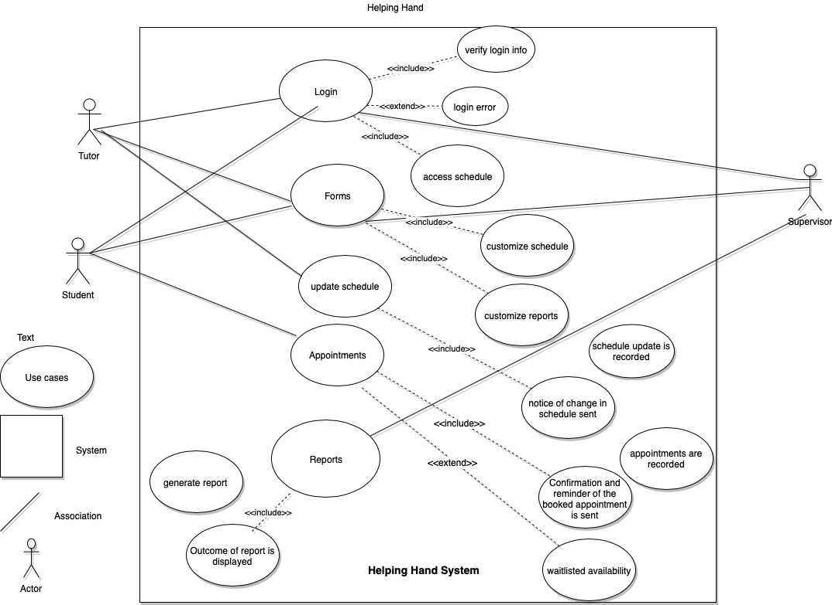

Planning as of D2

|  |  |  |  |  |
| --- | --- | --- | --- | --- |
| Task | Person | Time | Deadline | Submitted |
| Meeting (idea and role assignment) | Everyone | 7pm-8pm | 02/13/19 |  |
| Meeting D1 | Everyone | 7pm-8pm | 02/19/19 |  |
| System Request | Everyone |  | 02/20/19 | yes |
| Feasibility Analysis | Everyone |  | 02/20/19 | yes |
| D1 PPT Creation | Everyone |  | 02/20/19 | yes |
| Submit D1 | James |  | 02/21/2019 | yes |
| Meeting | Everyone | 7pm-8pm | 03/13/2019 |  |
| Interview and Requirement | Briana, Haythem, James |  | 03/26/2019 | yes |
| Use case document and diagram | Anusha, Timnit, and Daniel |  | 03/28/2019 | yes |
| Make a Gantt Chart | Timnit |  | 03/27/2019 | yes |
| Make PPT for D2 | Everyone |  | 03/28/2019 | yes |
| Screenshot KanbanFlow | Timnit |  | 03/28/2019 | yes |
| Submit Deliverable 2 | Timnit |  | 03/28/2019 | Not Yet |

Kanbanflow

